We make COBRA & Direct Billing administration simple – from start to finish.
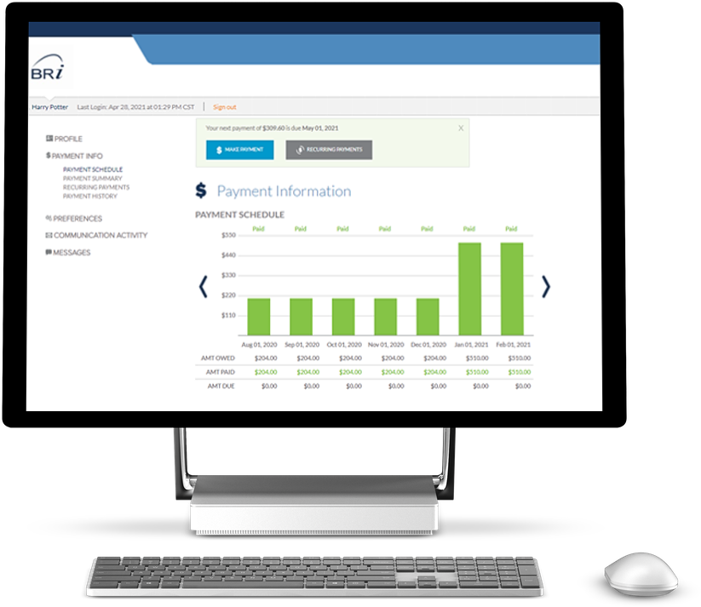
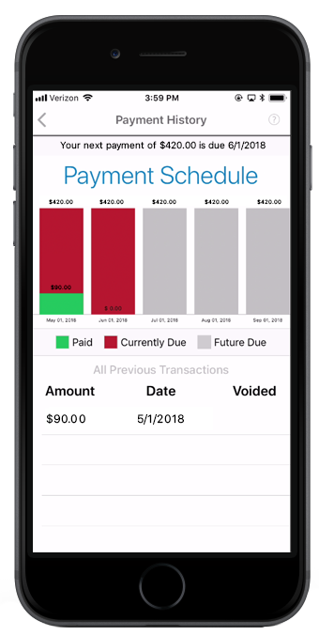
Managing COBRA and its associated compliance requirements is challenging. Plus, manual invoicing and payment processes can take a toll on your staff. At BRI, we’ve got the experience to ensure all communication, billing and collection processes are done right so you can rest easy whether you’re administering COBRA or managing other eligible premium collection processes.
Real-time access through portals and a mobile app means our COBRA & Direct Billing solution is always available and always accessible for you and your members.

Who should care about COBRA? You!  The Consolidated Omnibus Budget Reconciliation Act of 1986 (COBRA) requires all businesses with 20 or more employees who provide employee benefits to offer extended coverage to all employees who are terminated, retire, or become deceased.  From eligibility tracking to monitoring timelines to managing the extensive list of notices that must be distributed, administering COBRA can be not only a tax on your already stretched HR staff, but it can be awkward communicating with former employees. Outsourcing these processes could be the right answer for you. | THE BRI DIFFERENCE  Changing legislation makes COBRA harder to administer, not easier. Choosing the right partner can make all the difference. You can count on our team to be there for yours.  - Experience working with clients of all sizes  - Ease of transition from current solution  - One invoice for all services, one dedicated COBRA/Direct Billing administrator  - Data when and how you want it  - Highly knowledgeable COBRA experts
We take care of everything.
Implementation  Plan & Takeover Processing  Gather the required information to set up your plan(s) and identify any members that need to transition. | Compliance  Manage COBRA timelines and ensure all regulation language is included in required communications.  State Continuation options available. | Communications  Ensure members receive timely communication including all COBRA required notices (i.e. Specific Rights Notices, payment coupons, monthly statements, open enrollment notices, and more).  Online or paper enrollment options available.
Fulfillment  Send communications within COBRA regulations, bar coded, and all mailed letters date/time stamped, using the industry’s only “postmark date aware” lockbox. | Premium Collection  and Remittance  Collect the premium due and provide accurate administration including remittance and accounting reports. Electronic and paper check payments allowed. | Termination  End of COBRA  Automatically track when a COBRA member should be terminated (e.g. due to non-payment, end of coverage period) and issue the required notices.
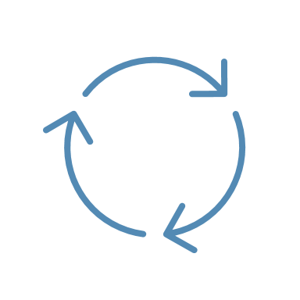  Plan Renewal Processing  Modify plan setup including the ability to support many complex plan and rate structures and issue rate change notifications. | Reporting  Provide full transparency into enrollments/ payments in a variety of formats. Reports are available OnDemand or can be scheduled via the Employer Portal. | Direct Billing Options  Flexibility to accommodate numerous direct billing scenarios including COBRA, leave of absence (LOA), long-term disability (LTD), retiree, pet insurance, state continuation and many others.
From implementation to reporting, we’ve got your COBRA and direct billing needs covered, including:
Let us do the heavy lifting.
With BRI COBRA & Direct Billing, we take the weight of COBRA compliance and the challenges of direct billing off your team’s shoulders so you can focus on active employees. Contact us at ae@benefitresource.com to learn more about our COBRA & Direct Billing services.
Let us do the heavy lifting.
With BRI COBRA & Direct Billing, we take the weight of COBRA compliance and the challenges of direct billing off your team’s shoulders so you can focus on active employees. Contact us at ae@benefitresource.com to learn more about our COBRA & Direct Billing services.

